Day 7 Java Basics
Variable: Container to put the Data
Data Types: 1 premitinve : Int Char float
2 non primitive : String, Array

1st we always declare a variable.
Variable can be X, Y, Name anything.
Declaring a variable: int -->data type ;int age;
Char name;
2nd assigning value to variable:
Age =10;
Name=’Nihar’;

3rd Declaring and assigning variable:
Int age = 20;
Char name =”m”;

Method:
Mainhead of your programmeentry and exit of the programme
public static void main(String[]args){
//body of the main
}

Above : Void === > is the return type== > return 0 value== success
int add(){
int x=20;
return x;
}
static == >means fixed == > retains its previous values…..eg: did we learn linux. Meaning remembering its value till the end. Therefore the Main method has to be static.
Where as Variables are not static as they don’t remember the value till the end.

Try in C:
====+++++=====++++
#include <stdio.h>

int add()
{ int x=10;
static int y=20;
x++;
y++;
printf("%d\n",x);
printf("%d\n",y);
}

void main() {
add();
add();
add();

}
=====+++++======+++++++=====+++++
Coming back to Java:
class Main{
public static void main(String[] args){
System.out.println(“Hello how are you”);
}
}
Task 001 Java:
Write a programme to display Greetings: 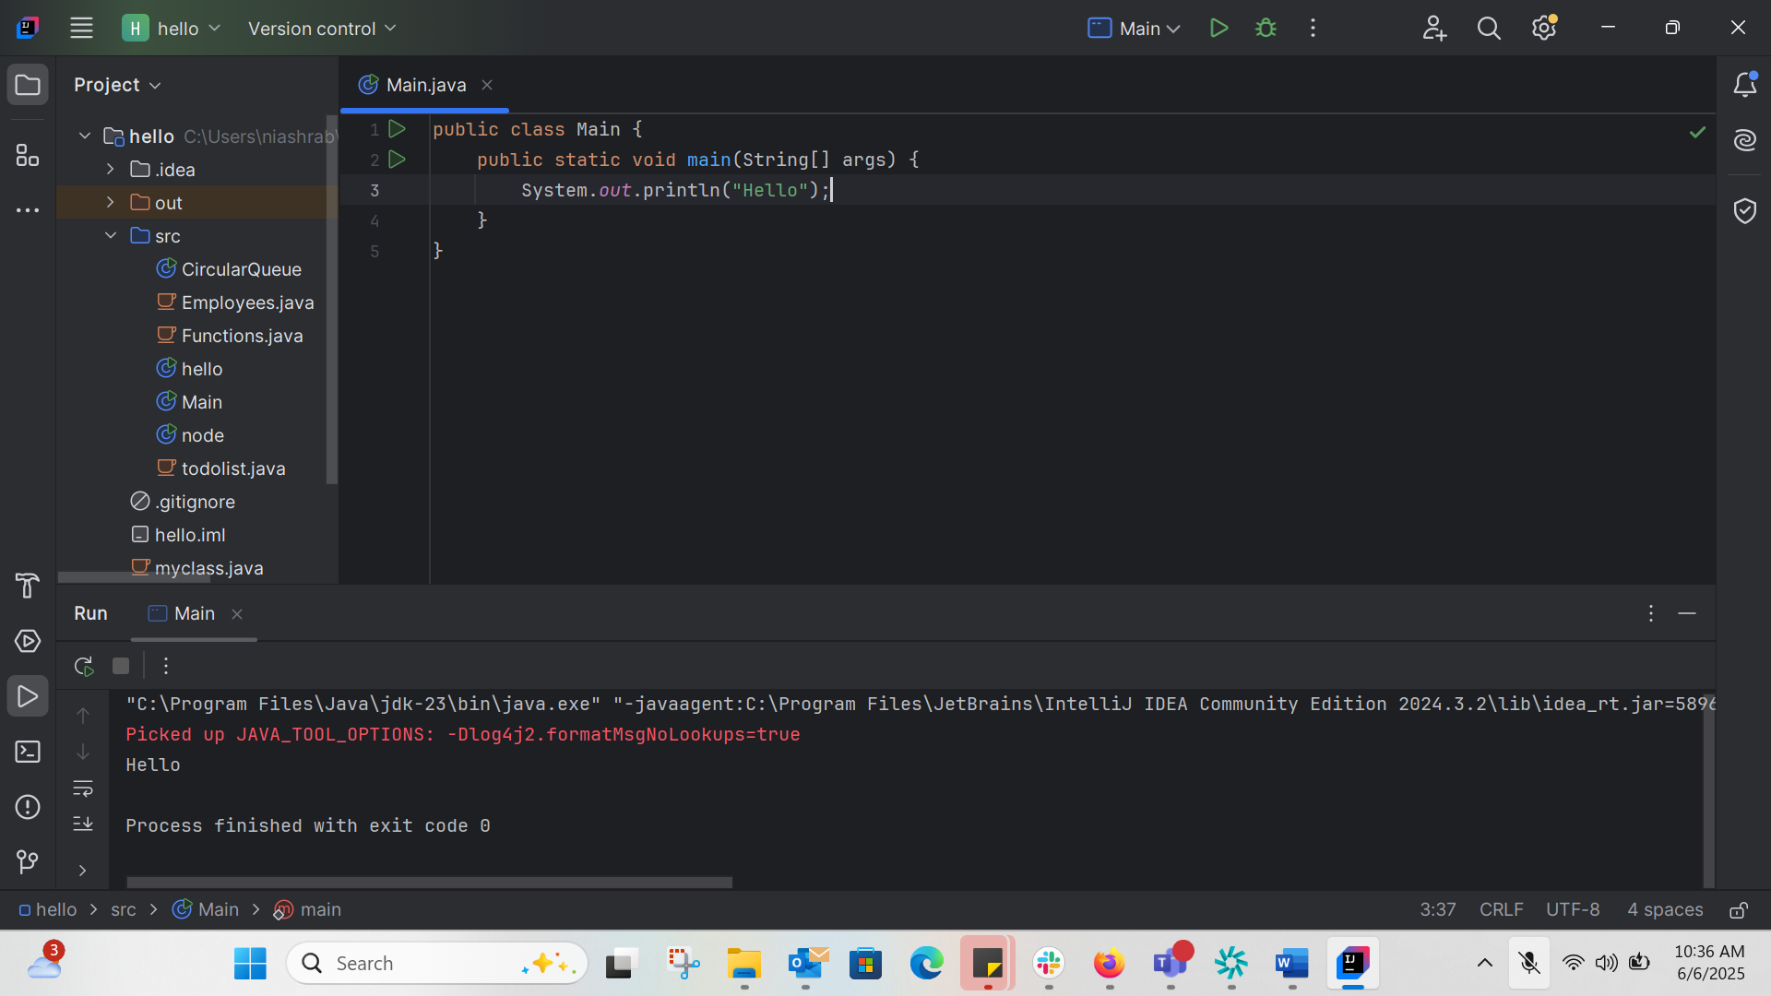
Tash 002 Java:
Wap to create a add method and call the method 3 times ..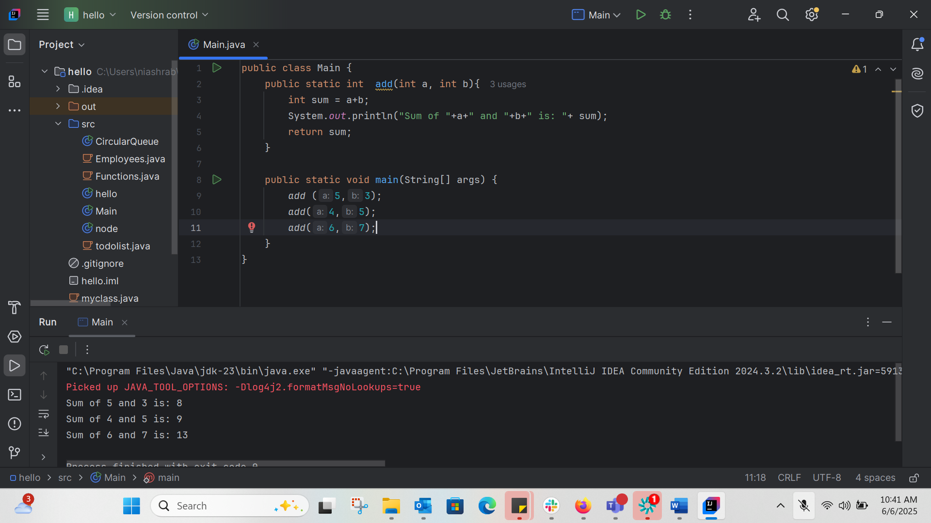
TASK 003:
Write a Program in Java to Add two Numbers.
Input: 2 3
Output: 5
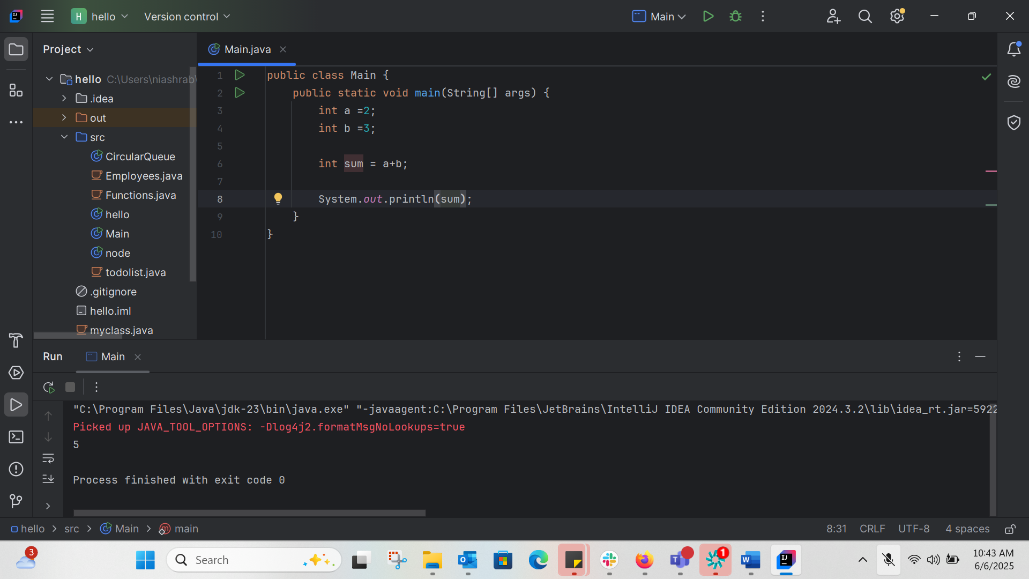
TASK 004
Write a Program to Swap Two Numbers
Input: a=2 b=5
Output: a=5 b=2
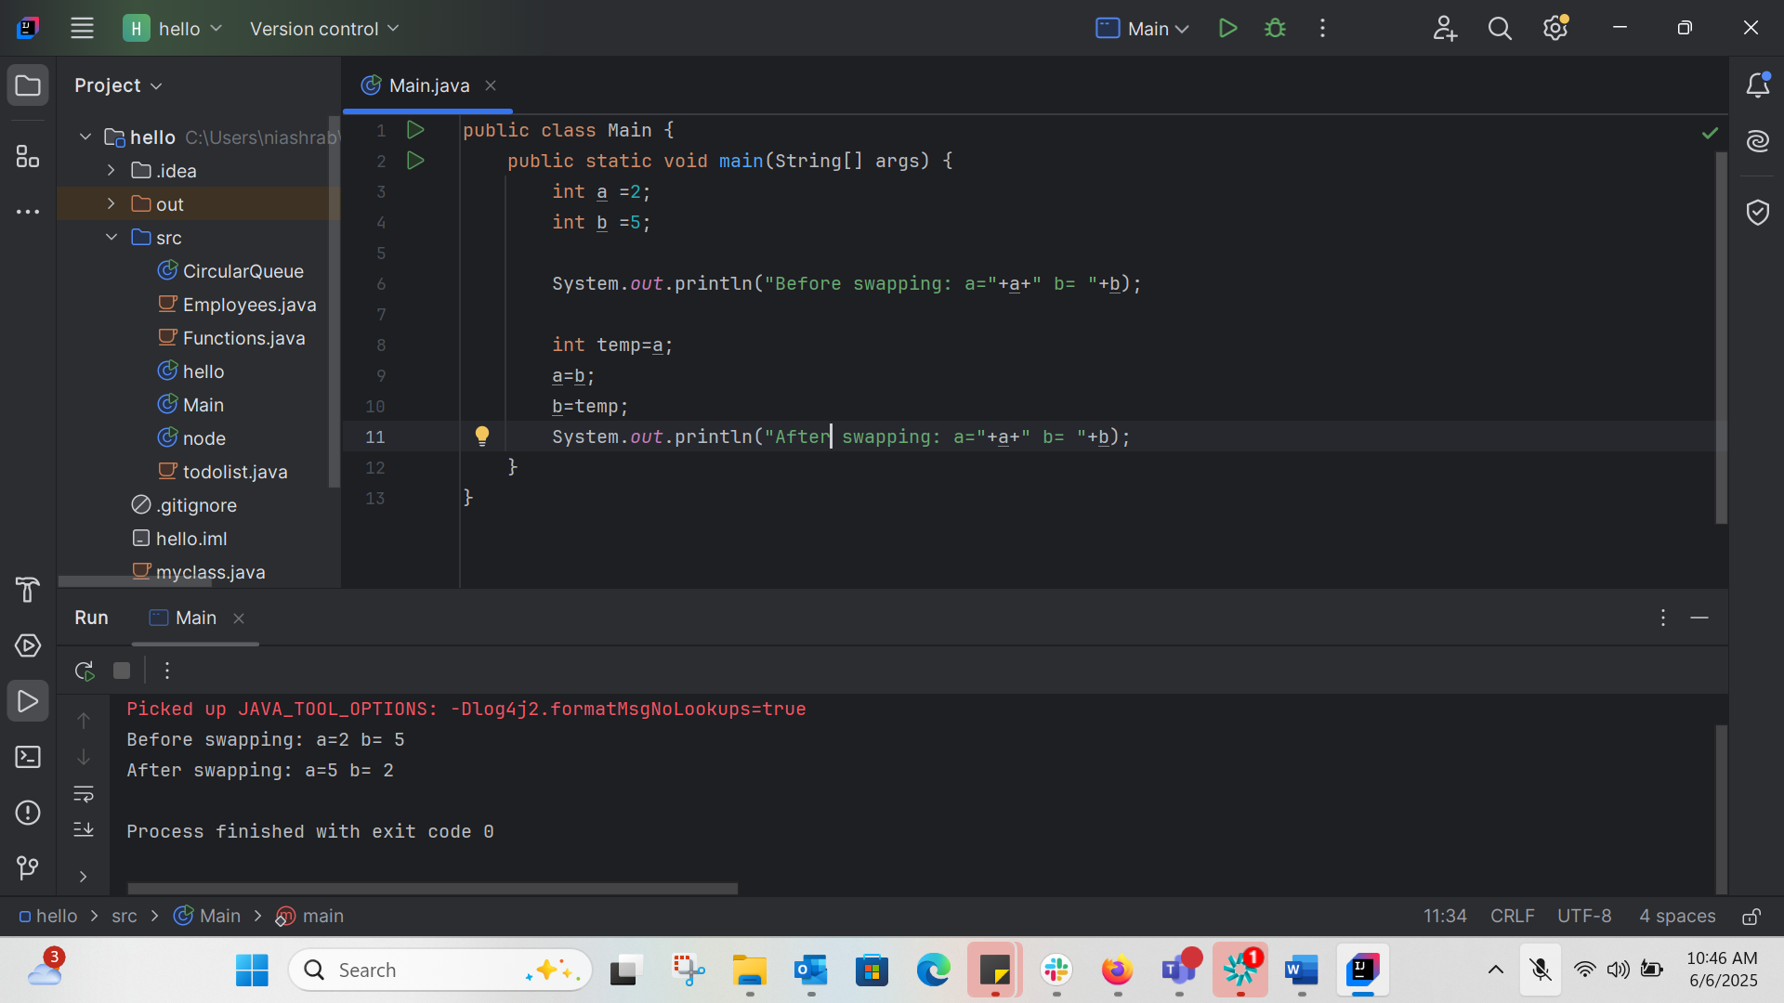
TASK 005:
Create a code in which you have 4 methods add, subtract, multiply and divide (return type int) with a main method..to call all the other methods
public class Main {
public static int add(int a, int b) {
return a + b;
}
public static int subract(int a, int b) {
return a - b;
}
public static int multiply(int a, int b) {
return a * b;
}
public static int divide(int a, int b) {
if (b != 0) {
return a / b;
} else {
System.out.println("Cannot divide by 0");
return 0;
}
}
public static void main(String[] args) {
int a=10;
int b=5;
System.out.println("Addition: "+add(a,b));
System.out.println("Subract:"+subract(a,b));
System.out.println("Divide: "+divide(a,b));
System.out.println("Multiply: "+multiply(a,b));
}
}
OUTPUT:
Addition: 15
Subract:5
Divide: 2
Multiply: 50

TASK 006:
Check if a is greater than b using ternary operator:
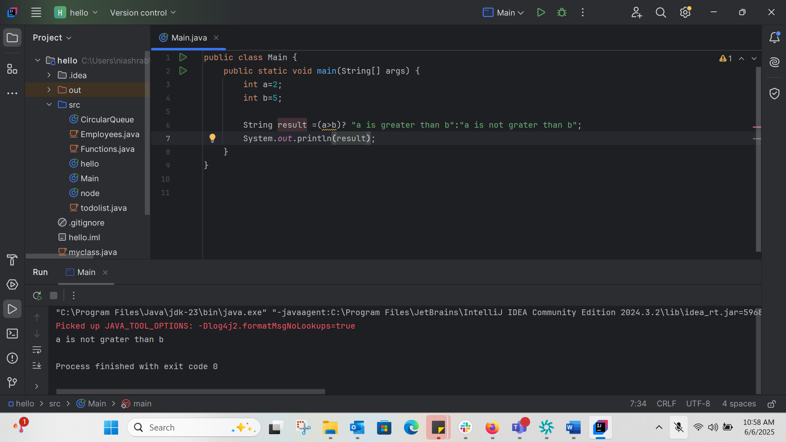
TASK 007:
Write a program to take input from the user and display it to the user
import java.util.Scanner;
public class Main{
public static void main(String[] args) {
Scanner scanner= new Scanner(System.in);
System.out.println("Please enter your id:");
String id= scanner.nextLine();
System.out.println("Please enter you password: (use numbers)");
int passwprd = scanner.nextInt();
System.out.println(" Hi,");
System.out.println("Your login ID is "+ id );
System.out.println("Your password is :"+passwprd);
}
}
Please enter your id:
niashrab
Please enter you password: (use numbers)
12345
Hi,
Your login ID is niashrab
Your password is :12345
Task 008:
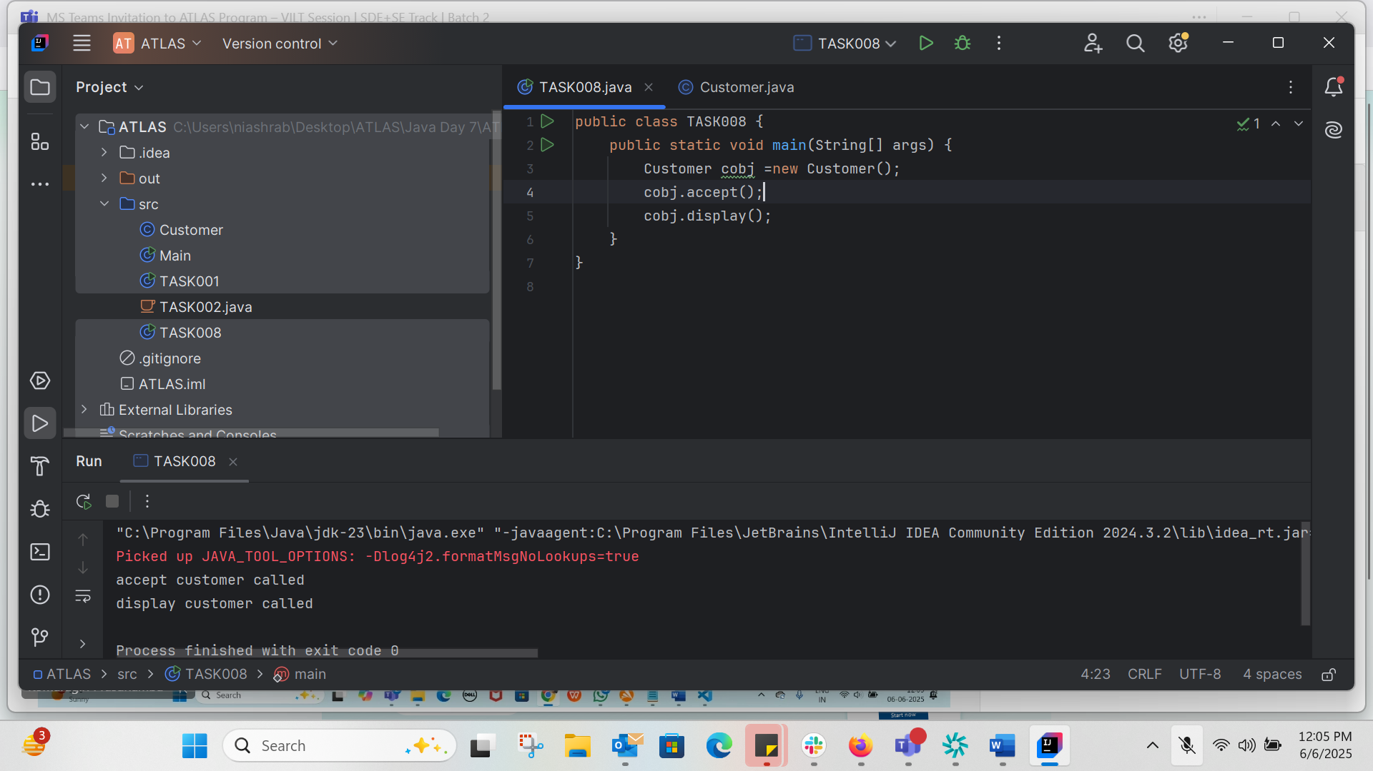
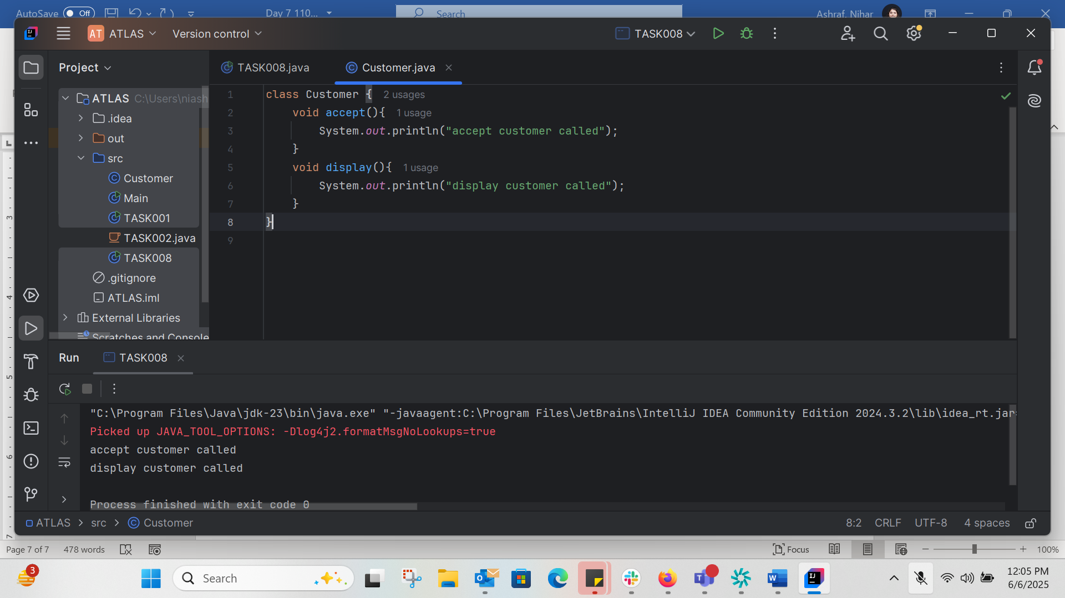
accept customer called
display customer called
TASK 009:
Wap to check the greater of 2 numbers
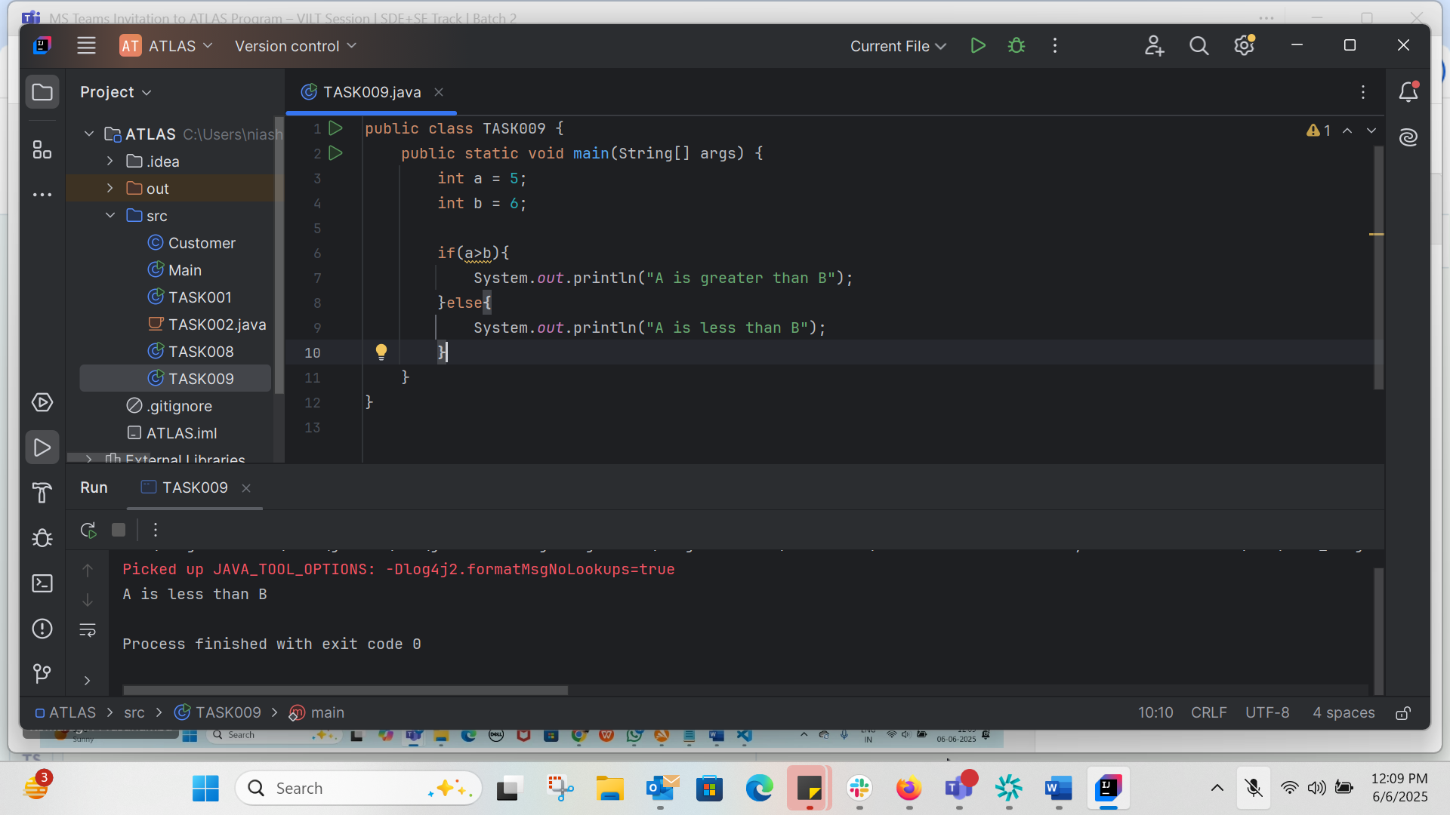
TASK 010:
Wap to check greater of 3 numbers
import java.util.Scanner;
public class TASK010 {
public static void main(String[] args) {
Scanner scanner = new Scanner(System.in);
System.out.println("Enter the first number: ");
int a = scanner.nextInt();
System.out.println("Enter the second number: ");
int b = scanner.nextInt();
System.out.println("Enter the third number: ");
int c=scanner.nextInt();
if(a>=b && a>=c){
System.out.println("Greatest number is:"+a);
}else if(b>=a && b>=c){
System.out.println("Greates number is:"+b);
}else {
System.out.println("Greatest number is: "+c);
}
}
}
OUTPUT:
Enter the first number:
5
Enter the second number:
6
Enter the third number:
7
Greatest number is: 7

TASK 011:
Wap to check if week days

1 ===> sunday
2 ===> monday
So on

8 and above ===> invalid input
import java.util.Scanner;
public class TASK011 {
public static void main(String[] args) {
Scanner scanner=new Scanner(System.in);
System.out.println("Enter a number from 1-7 to know the days of the week: ");
int num = scanner.nextInt();
switch (num){
case 1:
System.out.println("Sunday");
break;
case 2:
System.out.println("Monday");
break;
case 3:
System.out.println("Tuesday");
break;
case 4:
System.out.println("Wednsay");
break;
case 5:
System.out.println("Thursday");
break;
case 6:
System.out.println("Friday");
break;
case 7:
System.out.println("Saturday");
break;
default:
System.out.println("Invalid input! Please enter a nuber between 1 and 7.");
}
}
}
Enter a number from 1-7 to know the days of the week:
5
Thursday

TASK 012:
import java.util.Scanner;
public class TASK012_While_loop {
public static void main(String[] args) {
Scanner scanner = new Scanner(System.in);
String loginid;
String password;
int count =0;
while (true){
System.out.println("Enter your login ID: ");
loginid= scanner.nextLine();
System.out.println("Enter your password: ");
password=scanner.nextLine();
if (loginid.equals("Nihar")&& password.equals("1234567")){
count++;
System.out.println("You have logged in for "+count+" times.\n");
}else {
System.out.println("Invalid login or password. Try again.\n");
}
}
}
}
Enter your login ID:
faizal
Enter your password:
4567
Invalid login or password. Try again.

Enter your login ID:
nihar
Enter your password:
1234
Invalid login or password. Try again.

Enter your login ID:
Nihar
Enter your password:
1234567
You have logged in for 1 times.

Enter your login ID:

TASK 13:

public class TASK013 {
public static void main(String[] args) {
for (int i=10; i>0; i--){
if(i==7||i==5){
continue;
}
System.out.println(i);
}
}
}
10
9
8
6
4
3
2
1

TASK14:
package Arrays;
public class TASK014 {
public static void main(String[] args) {
char[] arr={'a','e','i','o','u'};
System.out.println(java.util.Arrays.toString(arr));
String[] names={"Meena","Teena","Veena","Heena"};
System.out.println(names[0]);
names[1]="Reena";
System.out.println(names[1]);
System.out.println(names.length);
System.out.println(names[4]);
}
}

Since array length is only 4 and there no element in -1, 4, 5 we are getting error.

TASK 15:
package StringHandeling;
public class TASK015 {
public static void main(String[] args) {
String str1 = "Java Strings";
String str2 = new String(str1);
String str3 = new String("are easy to learn");
char[] ch = {'S','t','r','i','n','g'};
String str4 = new String(ch);
System.out.println("str1: "+str1);
System.out.println("str2: "+str2);
System.out.println("str3: "+str3);
System.out.println("str4: "+str4);
}
}
str1: Java Strings
str2: Java Strings
str3: are easy to learn
str4: String

TASK 016:
Enums or Enumerations – part of collection framework

What is the output of the below code snippet
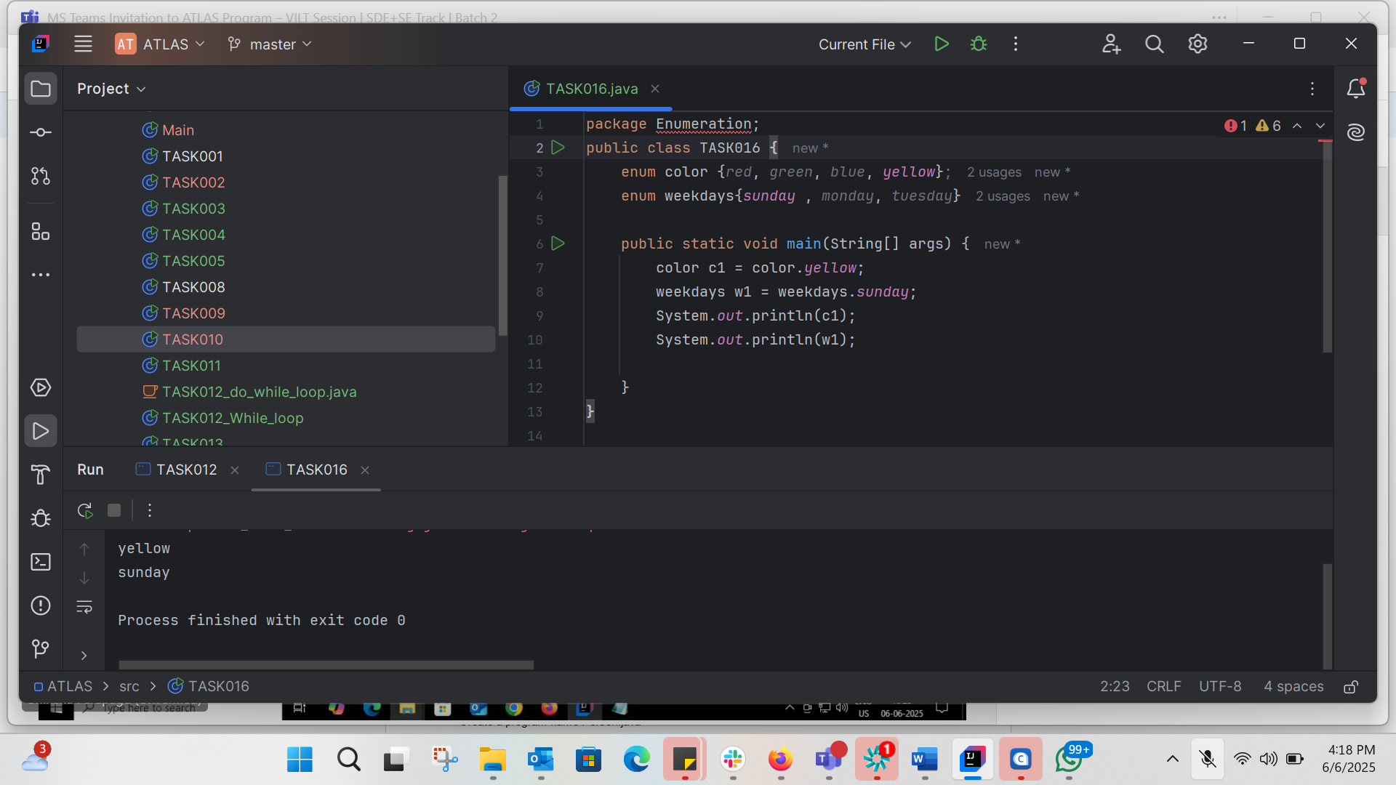

TASK 017:
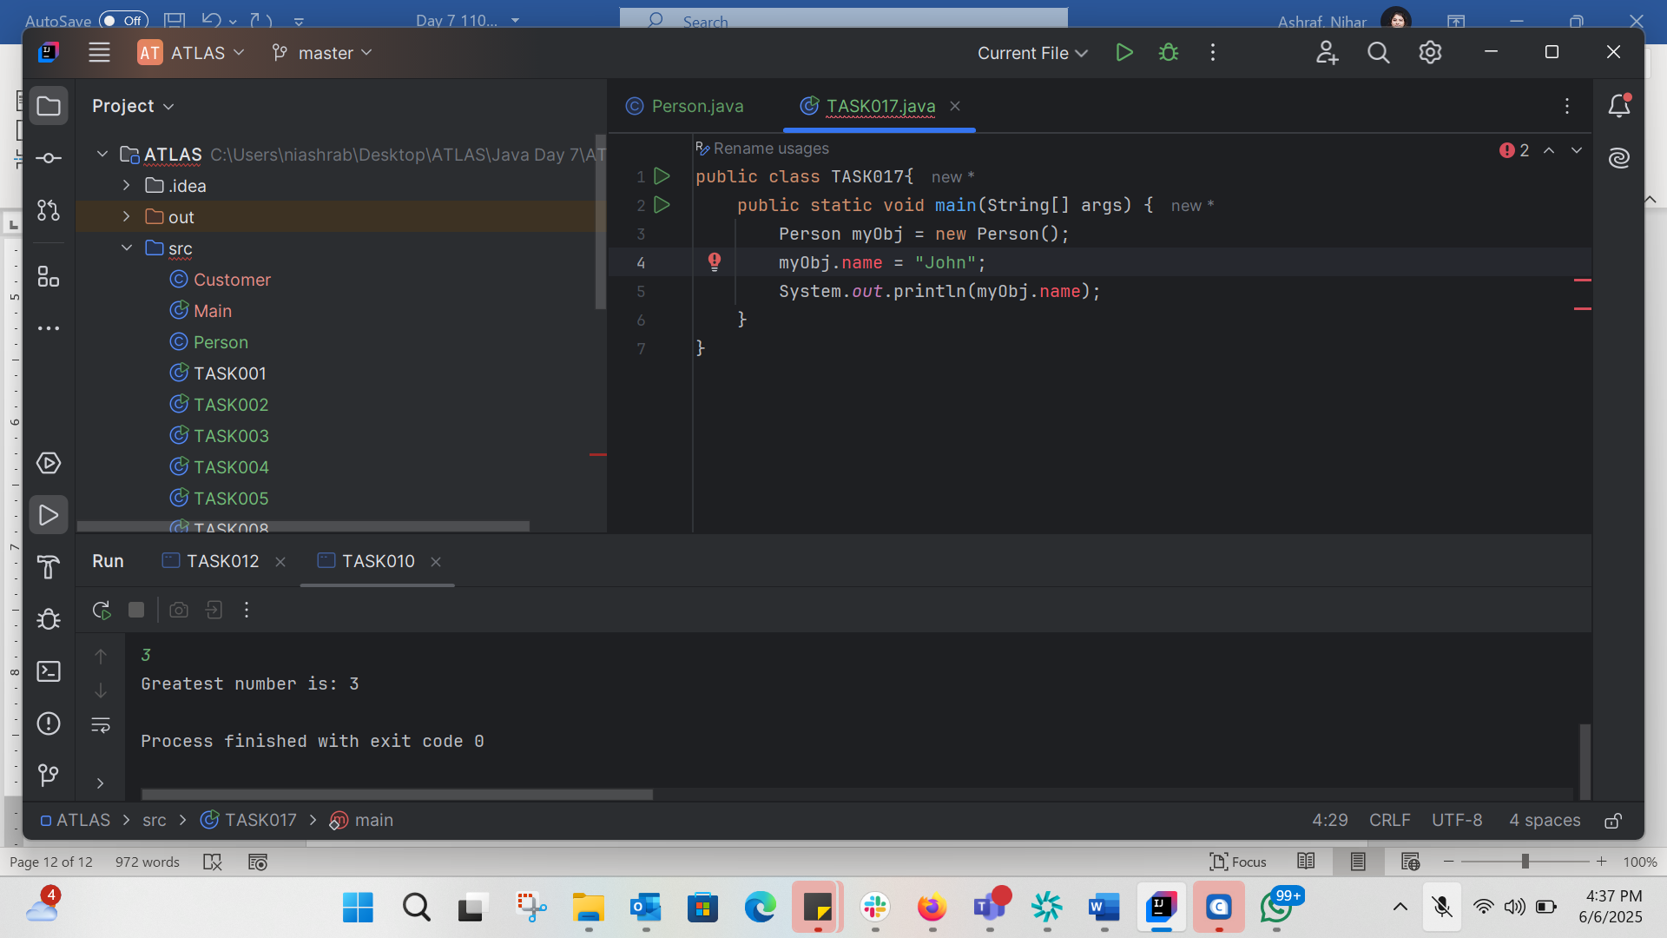
Name is declared as private in the Person class, which means it cannot be accessed directly from another class

Corrects:
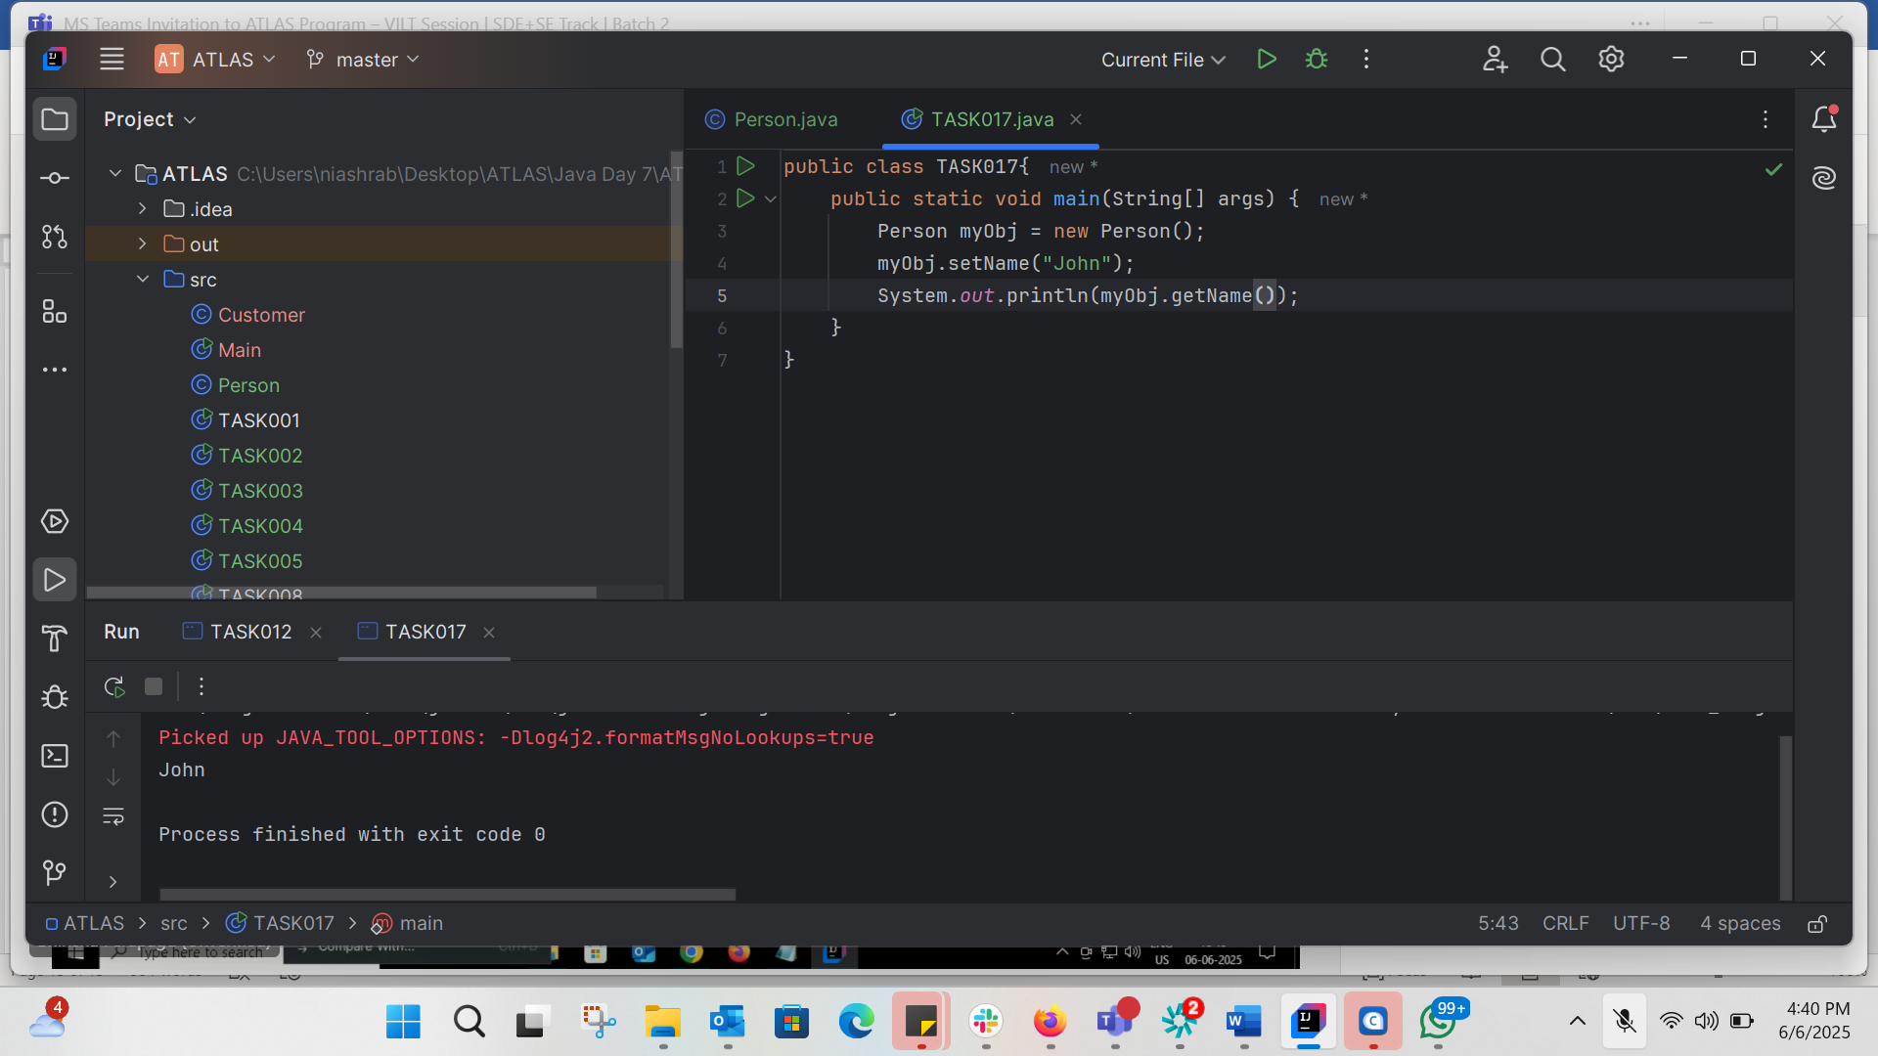

Task 18:
Corrected of TASK 17
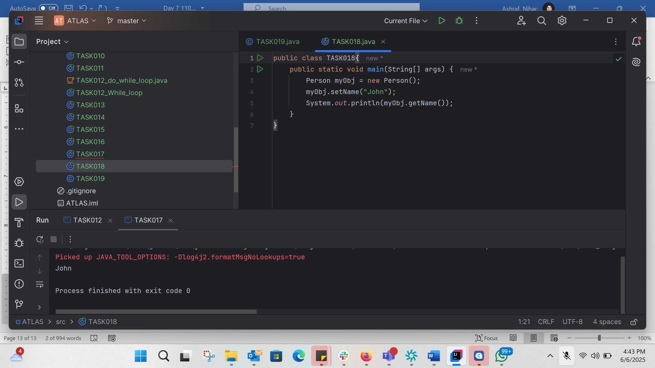
TASK 19:
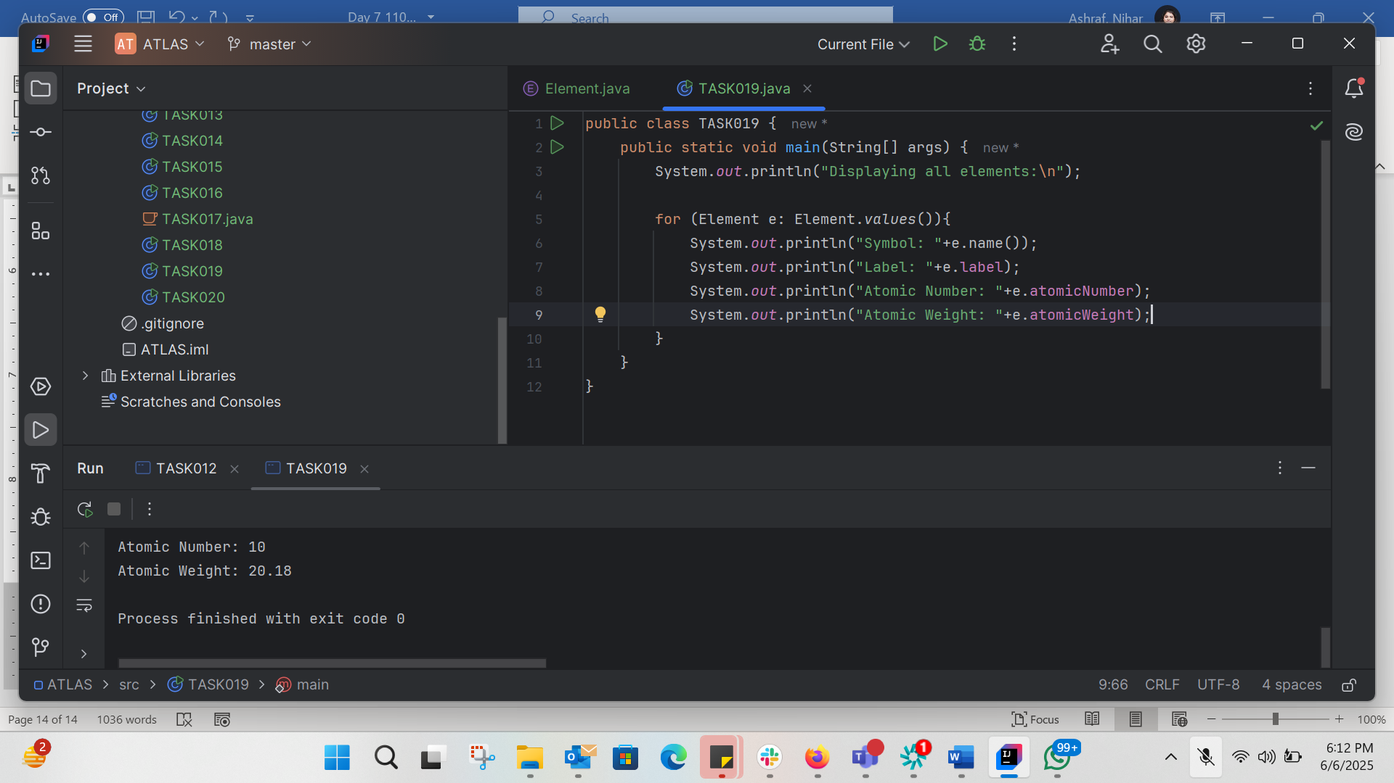

TASK20:
public class TASK020 {
public static void main(String[] args) {
char[] Name={'N','i','h','a','r'};
System.out.println(Name);
int n = Name.length;
System.out.println("There are "+n+" letter in my name.");
System.out.println("Letter are: ");
for (int i=0;i<n;i++){
System.out.println(Name[i]+" ");
}
}
}

